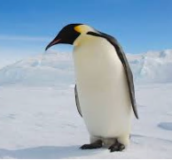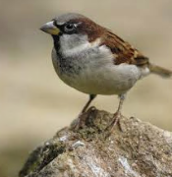

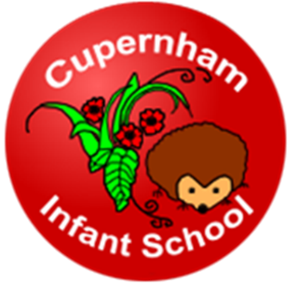

Welcome to Penguins, Sparrows and Wrens

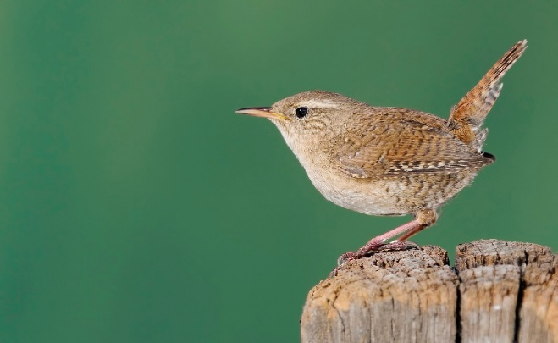



People you will get to know around school;

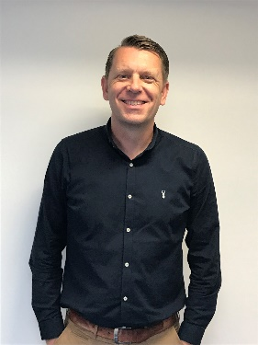

**Mr Wells**

Head Teacher

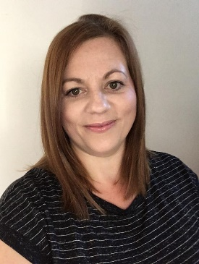

**Mrs Turski**

Deputy

Head Teacher

**Sometimes you may see these people in and around the classroom and school and sometimes they will lead assemblies.**



**Your new teachers…**

**Your new teachers…**

**Penguins**

**Mrs Platt** **Mrs Lake Mrs Brown**

Year R Leader & Class Teacher LSA LSA & Speech & Language

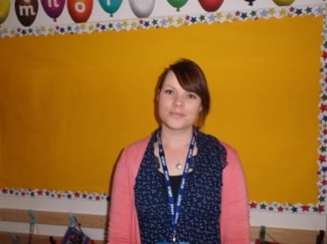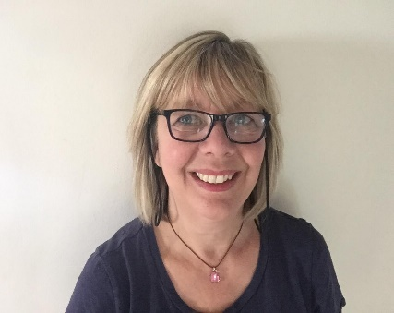 Support

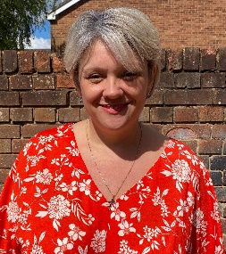

**Sparrows**

**Miss Bailey** **Mrs Codling**

Class Teacher LSA

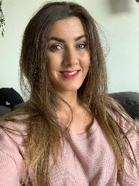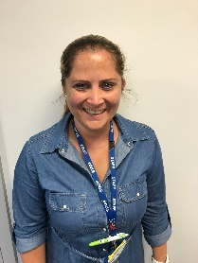

**Wrens**

**Mrs Hellings/Miss Lowden** **Mrs Kibbey**

Class Teachers LSA

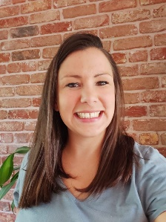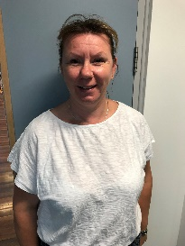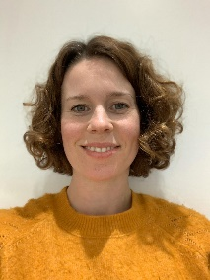

**Other people who help us… Mrs Pattison**

Special Educational Needs Coordinator

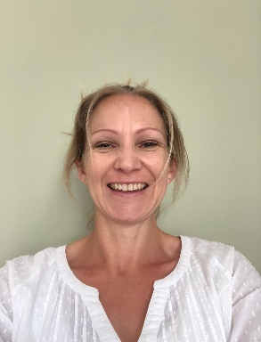

**Mrs Blofield** **Mrs Whitfield**

HLTA HLTA

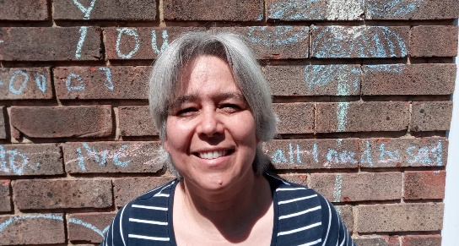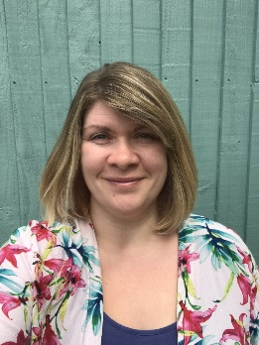

**The office staff…**

**Mrs Cron** **Mrs Thompson** **Mrs Woffenden**

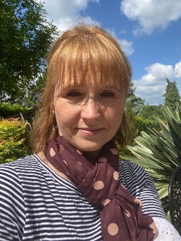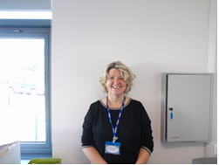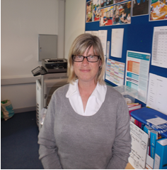

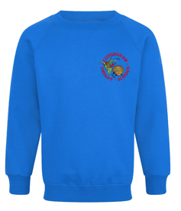**When you come to school you will wear a smart uniform;**

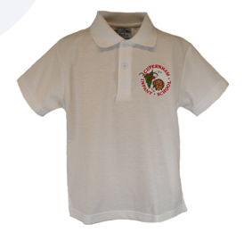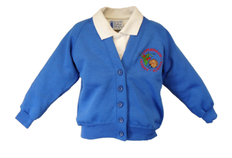Our Uniform is electric blue with our ‘hedgehog’ logo.

Boys can wear black or grey trouser or shorts.

Girls can wera black or grey trouser, skirt or pinafore dress.

**We are very active and do P.E. at school. We wear a P.E. Kit, this lives on your peg.**

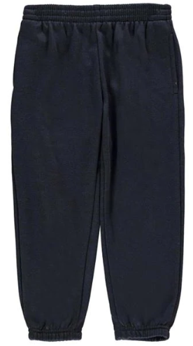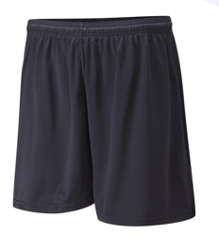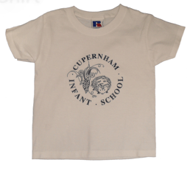

**Shorts, t-shirt, jogging bottoms and sweatshirt, short socks, trainers (plimsolls not essential) in a named PE bag. This does not have to have a logo on. We tie long hair back on PE days.**

**Please ensure that all items of uniform and PE kits are named please.**

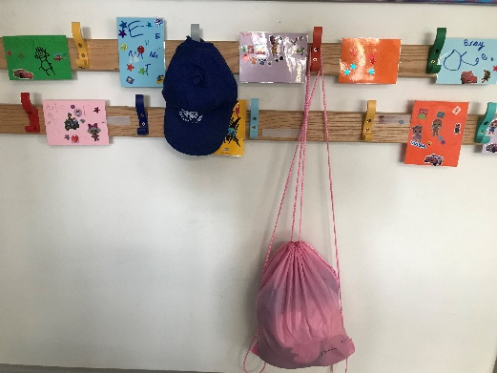**The classrooms…**

You will have a

peg to put your

coat and P.E. bag

on.

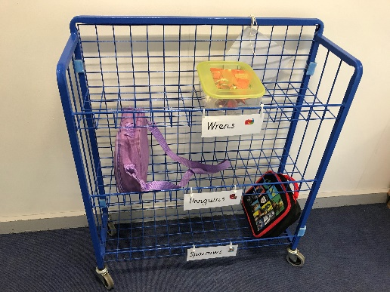

There is a trolley for your lunch box.

There is a box for your book bag.

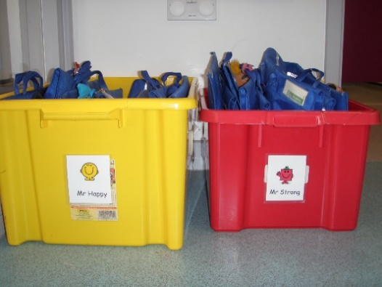

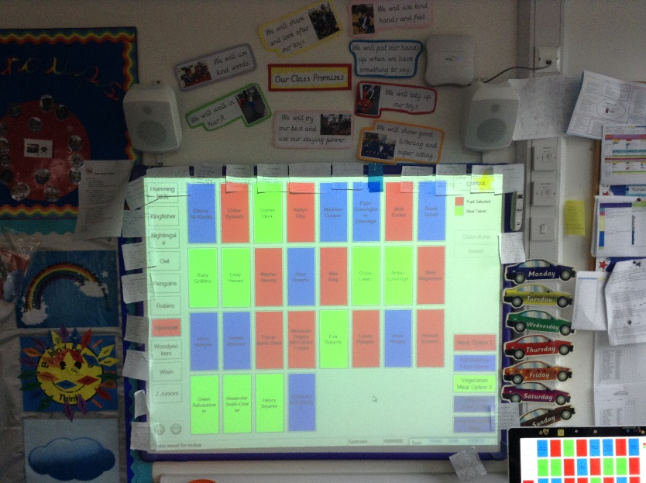

When you stay for lunch, you will choose the lunch you are having using the whiteboard, an adult will help you.

**Lunchtime…**

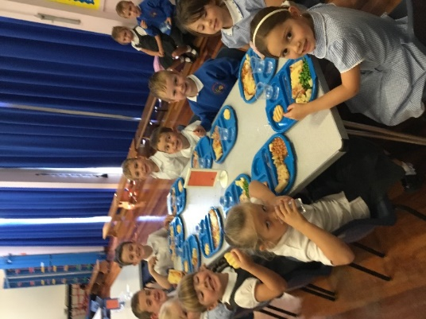

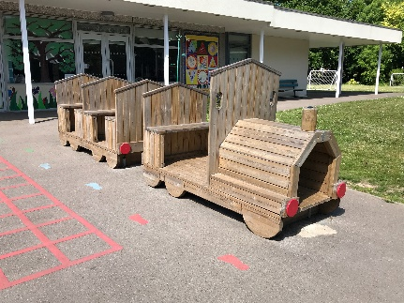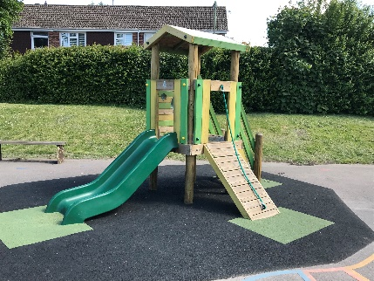

You will eat your lunch in the hall.

Then you will play out on the playground.

**People who help us at lunchtime…**

Mr Whalvin Mrs Lewis

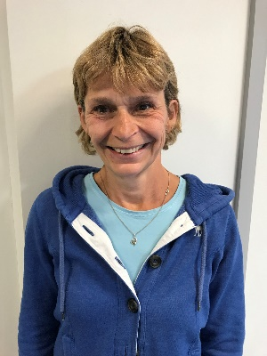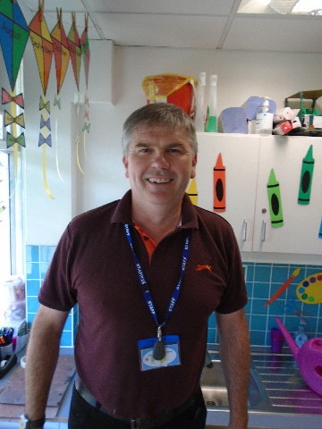

**….And many more adults**

**You will have a lot of fun in Year R…**

