**MATHS**

This half term we will be learning to recognise coins and notes. We will be using our addition skills to combine coins to make amounts.

We will then be learning our times tables (2s, 5s and 10s). We will be recording these using jottings but will be working on rapid recall of multiplication facts.

The children will also be recapping how to tell the time to o’clock and be taught how to tell the time to half past.

**Key vocabulary** – times table, o’clock, half past, half, quarter, pounds, pence.

**LITERACY**

We will be learning to write firework poetry and how we can use alliteration and adverbs to make our poems exciting.

This half term we will be looking at a book with a little girl who finds a dinosaur and wishes it to come to life.

We will be learning to use exclamations and commas too.

**Key vocabulary** – comma, exclamation mark, poem, alliteration.

History- Mary Anning

We will be learning all about the incredible life of Mary Anning. We will be looking at her early life and then how her ‘curiosities’ were noticed by a scientist.

We will be learning about why her discover of fossils was so important and how it shapes out lives today.

**Key vocabulary** – fossil, Jurassic coast, Lyme Regis, discovery, Scientist.

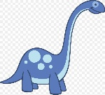

Journeys

##### PSHE

As part of Jigsaw we will be ‘Celebrating difference’ this half term. We will be challenging gender stereotypes and learning about how to talk about our differences in a positive way.

ROLE PLAY:

Castle

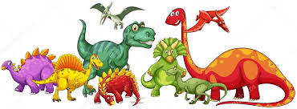

### THE ARTS AND DT

**ART & DT**:

We will be having a focused week linked to Diwali where we will be learning to use clay. We will be adding texture using tools and ‘slip’ to join 2 pieces of clay together.

Later in the term we will be honing out sketching skills and using different pressure on a pencil to sketch a fossil.

**Key vocabulary** – sketch, slip, clay, texture.

**MUSIC**:

We will be singing our Christmas songs. We will be learning how to stay on time and how to learn words. We will also be learning to control our voice to enable us to perform songs well.

**Key vocabulary** – timing, verse, chorus.

**RE**

As we approach Christmas, the children will be learning about Angels and what they mean to different people and religions. We will also be teaching children the events of the Christmas story from the Bible.

As part of Diwali week, we will be exploring the story of Rama and Sita and the Hindu faith.

**Key vocabulary** – angel, believe, Hinduism, Rama, Sita, Christmas, Jesus.

**PE**

This half term our focus for PE is dance.

We will be creating and learning a firework dance using levels, rolls, balances and cannon.

**Key vocabulary –** Teamwork, core, balance, travel, cannon, 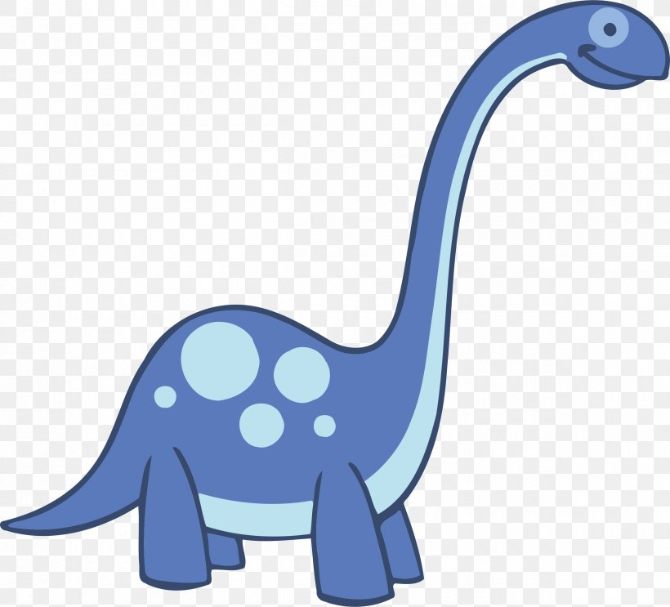

###### COMPUTING

We will be developing our word-processing skills and will be using technology purposefully as a recording tool within our learning. We will be exploring how to change the size, colour and effect of fonts.

**Key vocabulary** – font, shift, size, caps lock.

**KEY FACTS**

* Mary Anning found the first ever fossils of prehistoric animals.
* Mary Anning found fossils in Lyme Regis.
* She was the first person to find a complete ichthyosaurus fossil and she was known as the first woman palaeontologist.

**ROLE PLAY –** Fossil hunters.

**SMALL WORLD –** Dinosaurs

**KEY WORDS**

|  |  |
| --- | --- |
| knight | castle |
| armour | arrow |
| lady | battle |