Cupernham Infant School

Handwriting Policy

Approved: September 2022 by SLT
Reviewed: September 2023

Intent
At Cupernham Infant school, we are proud of our pupil’s handwriting and we place high value on children taking pride and care over their work. We use the Little Wandle programme as the basis of our handwriting policy in school which covers the requirements of the 2014 National Curriculum. Handwriting is a basic skill that influences the quality of work throughout the curriculum.
At the end of key stage 1, we intend to ensure pupils have the ability to know the importance of clear and neat presentation in order to communicate meaning through their writing effectively.
To write legibly with increasing fluency and speed by;
• Having a correct pencil grip
• Knowing the size and orientation of letters
• Forming all letters correctly
• Knowing that all cursive letters start from the line
We aim to make handwriting an automatic process that does not disrupt the creative and mental thinking of the children.
In Early Years, there is great emphasis upon gross motor skills and fine motor skills. We use a range of resources and activities to practice these basic skills. This moves onto correct letter and number formation with a focus on both upper-case and lower-case letters. We use the phonics programme ‘Little Wandle’, and their unique formation rhymes, to help the children with the formation of clear pre-cursive letters. This leads them into developing a print style of writing, which is a direction from within the 2021 statutory framework for the early years’ foundation stage.

What does handwriting look like at Cupernham Infant School?
- At Cupernham Infant School, handwriting will be timetabled for between 40 - 50 minutes per week, in short sessions, dependent on pupil age. This will be a whole class exercise in Year 2 and groups leading to whole class as the year progresses in Year 1. Children, who find handwriting difficult, will be targeted for regular intervention.
- Within the Early Years discreet teaching will start using the phonics programme Little Wandle. Children will start with pattern formation to ensure correct pencil grip and control. When ready, children are then taught how to form each letter correctly using print.
- As a school, we use Little Wandle to teach our children handwriting using progressive techniques as they move through Year groups. In Year 2, we begin to teach cursive lettering and diagonal joins using the Teach Handwriting scheme. If children are struggling to adopt a fluent handwriting style, immediate intervention by the teachers are used to support them through demonstrating letters within their handwriting books or returning to fine-motor skills to improve pencil grip.
- Alongside discreet sessions the children in the Early Years and those at the start of Year 1 will be provided with a range of pre-writing opportunities within their continuous provision.
- Incorrect letter formation must be picked up on in all lessons and corrected as soon as the child is forming letters.
- Children must start and finish the letter in the correct place according to the Little Wandle scheme.
- Extra handwriting groups can occur in classes throughout the school where the class teacher feels that additional handwriting support is required for children to succeed. For pre-writing, children will have access to gross and fine motor interventions to develop their pencil grip and control ready for handwriting. The ABC programme from The Solent Therapy Pack will form a starting point for these interventions.
- Displays of correct formation and alphabet mats are always available to the children so that they can refer to these when required.
- All staff model using print in the Early Years, Year 1 teachers move towards a cursive approach to handwriting using lead outs once the children are ready and ensure the children are ‘next phase ready’ and will begin a cursive approach in Year 2 using Teach Handwriting resources.
- On the website, parents have access to the schemes letter formation so they will have the same expectations. These will be shared at the first parents evening in term 1.

National Curriculum Guidance
Handwriting is not a specific focus in the EYFS curriculum, but it is part of Little Wandle Phonics teaching.
Year 1 Handwriting
Pupils should be taught to:
- sit correctly at a table, holding a pencil comfortably and correctly
- begin to form lower-case letters in the correct direction, starting and finishing in the right place
- form capital letters
- form digits 0-9 understand which letters belong to which handwriting ‘families’ (i.e. letters that are formed in similar ways) and to practise these.

Year 2 Handwriting
Pupils should be taught to:
- form lower-case letters of the correct size relative to one another
- start using some of the diagonal and horizontal strokes needed to join letters and understand which letters, when adjacent to one another, are best left unjoined
- write capital letters and digits of the correct size, orientation and relationship to one another and to lower case letters
Handwriting statements in the End of KS1 Framework 2019
WTS –form lower-case letters in the correct direction, starting and finishing in the right place. Form lower-case letters of the correct size relative to one another in some of their writing
EXS – form capital letters and digits of the correct size, orientation and relationship to one another and to lower-case letters.
GDS - use the diagonal and horizontal strokes needed to join some letters.
Handwriting Model used at Cupernham Infant School
Cupernham Infant School teaches letter formation using the Little Wandle Formation Phrases in EYFS and Year 1 using print and moving on to the introduction of using lead ins and lead outs. Year 2 move onto a cursive script using Teach Handwriting resources to supplement the Little Wandle scheme.
Teaching Sequence
We follow the Little Wandle teaching sequence for letter formation, starting in Term 1 of Year R.
https://www.littlewandlelettersandsounds.org.uk/resources/for-parents/

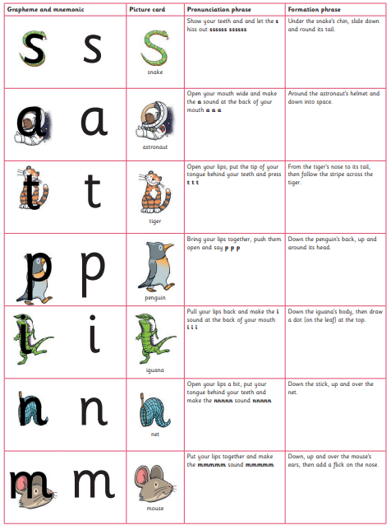
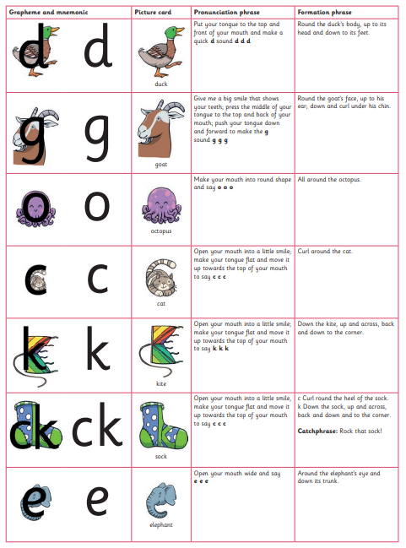
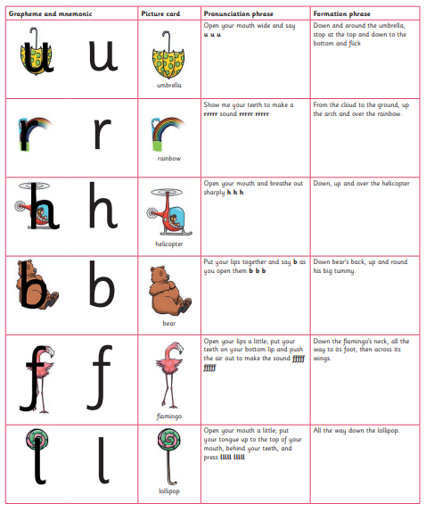
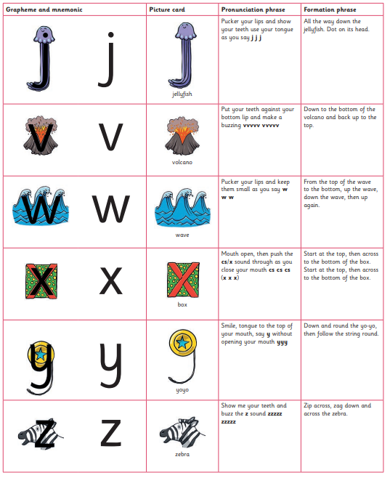

We then move to ‘Teach Handwriting’ to encourage fluid, diagonal letter joins and cursive writing.
More information can be found here: https://teachhandwriting.co.uk/
Curly Caterpillar Family:
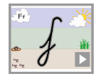

The Long Ladder Letter Family:
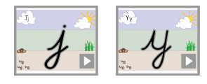
One Armed Robot Letter Family:
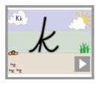
Zig Zag Letter Family:

Numbers:
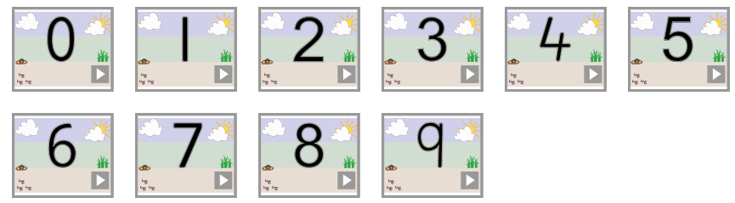

Number Formation Rhymes
Top to bottom then we’re done, this is the way we make a one.
A curl for me, a line for you, this is the way we make a two.
A curl for you, a curl for me, this is the way we make a three.
Down and across and then one more, this is the way we make a four.
Hat on top, take a dive, round we go that makes a five.
Stir it round, give it a mix, this is the way we make a six.
Across and down so easy its heaven, this is the way we make a seven.
Make an s, then close the gate, this is the way we make an eight.
Curl it round, then make a line, this is how we make a nine.

Capital Letters:
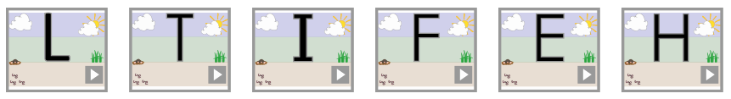
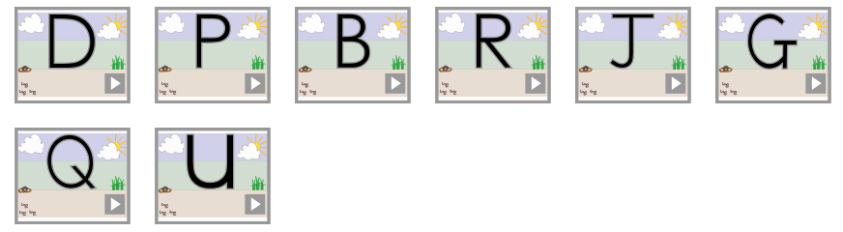
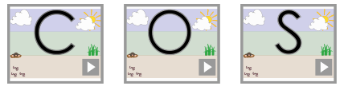
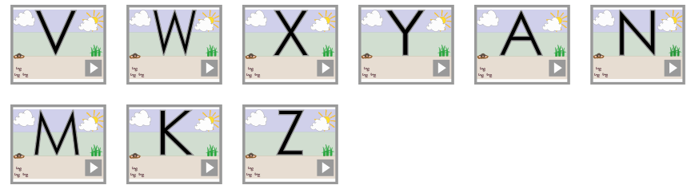

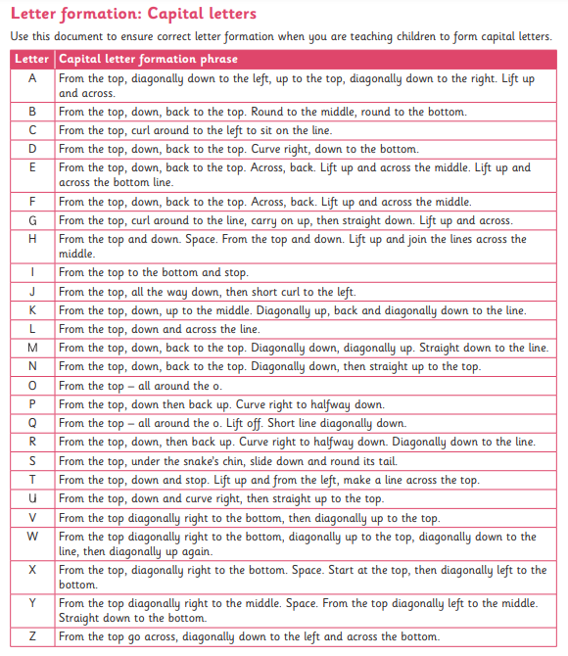

Year 1 will consolidate individual letter formation, by writing these as digraphs, trigraphs and words, following the Little Wandle teaching sequence. By Year 1, most children should be secure forming individual letters. However, some may still need small group support / intervention.
The formation of all capital letters and numbers will be taught in Year 1.

Year 2
Lead in and lead out strokes will be taught in Terms 1 and 2, followed by the introduction of the four handwriting joins.
- Diagonal joins to letters without ascenders
- Diagonal join to letters with ascenders
- Basic horizontal joins
- Horizontal joins with ascenders

Further Y2 Joins:
- practising joining the letter s
- practising joining from the letter r
- practising joining to and from the letter a
- practising joining from the letter e
- practising joining from the letter o
- practising joining to the letter y
- practising joining to the letter a
- practising joining to the letter r
- practising the horizontal join to the letter e
- practising the horizontal join to the letter u
- practising joining to ascenders

Recording
Children in Year R will have handwriting sessions and other practical kinaesthetic activities. They will follow the Little Wandle Progression sequence of letters, learning to form letters outside the daily Phonics lesson.
As motor skills increase then the size of writing should decrease. In Year 1, children should start using specific books with the four handwriting lines. This continues in Year 2.

Techniques for teaching letter formation
- Good handwriting and handwriting techniques will be modelled all the time.
- The handwriting process will be talked through and discussed.
- Children will be encouraged to verbalise the process.
- Children will form letters in the air.
- They will use fingers to trace over tactile letters.
- They may write in sand with a finger or stick or write on a chalkboard with chalk.
- Letters may be formed with pegs on pegboard or with beads in plasticine.
- They may use fingers to trace the outline of letters on the back of another person.

Getting ready to write
Seating and posture
- Children must sit up straight, with both feet firmly on the floor.
- Chair and table should be at a comfortable height.
- The table should support the forearm so that it rests lightly on the surface and is parallel to the floor.
- The height of the chair should be such that the thighs are horizontal and feet flat on the floor.
- Rooms should be well lit.
- Left handed pupils should sit on the left of their partners.

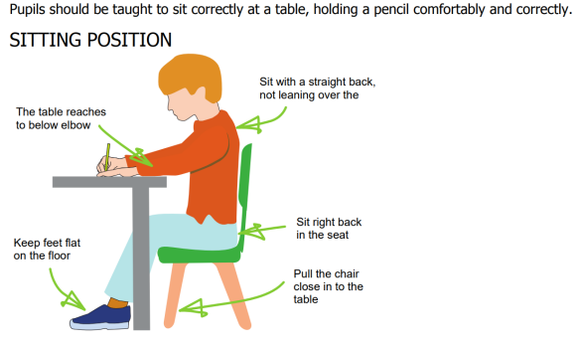

Pencil Grip
A tripod grip is the most efficient way of holding a pencil

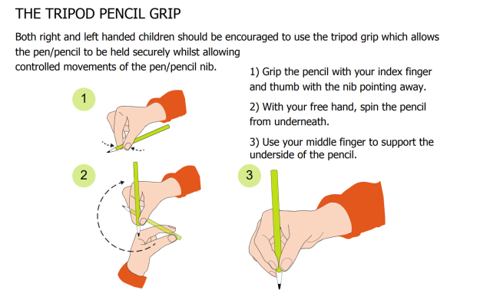
Different styles of pencil grips and slope boards are available for those who would benefit from them.
For Right Handers
- Hold lightly between the thumb and forefinger about 3cm away from the point
- The paper should be placed to the right tilted slightly to the left
- Use the left hand to steady the paper

For Left Handers
- Hold lightly between thumb and forefinger resting on the first knuckle of the middle finger
- Hold about 3cm from the tip
- The hand should be kept below the writing line
- The paper should be tilted slightly to the right at about 20 - 30°
- Use the right hand to steady the paper

NB It is very important that a right handed child does NOT sit on the left hand side of a left handed child as their elbows will collide.

Links to spelling
Linking handwriting with spelling is one of the most powerful ways of developing the visual memory. Handwriting will be practised using letters, digraphs and high frequency words so that patterns are internalised.
Remember to use Look – Say – Cover – Write – Check

Assessment
Class teachers will continually monitor pupil progress in comparison with the age appropriate order of teaching. Handwriting from each year group will be reviewed and discussed at whole school writing moderation.

Impact:
Our policy enables pupils to develop a neat, legible handwriting style using continuous cursive letters by the end of Year 2 that leads to producing letters and words automatically in independent writing.
EYFS:
By the end of the EYFS, children will be able to:
- Begin to sit in the correct position and hold a pencil correctly to allow fluid movement of the tip.
- Improve fine and gross motor skills by enjoying drawing print patterns in a variety of writing materials such as: modelling clay, air writing, and sand trays, felt pens, crayons, pencils, IWB, and iPads or tablets.
- Understand the language needed to describe pencil movements in preparation of letter formation.
- Hold a pencil in an effective manner for writing and be encouraged to correct any errors in grip or stature
- Understand that letters are written on a base line and that all letters start from the same place.

KS1
By the end of KS1, children will be able to:
- Write legibly using upper and lower case letters with correct joins.
- Ensure that letters sit on the base line and are consistent in size with ascenders and descenders that are the correct length and formation.
- Leave the correct space between words.
- Form capital letters and use where appropriate.
- Form numerals that are consistent in size and sit on the base line.
- Begin to form printed letters and understand when they are to be used.
- Improve the speed of writing and begin to write automatically so promoting creativity in independent writing.

