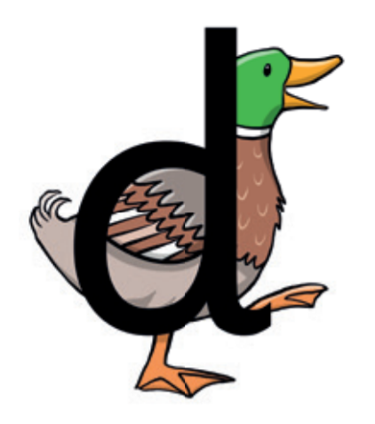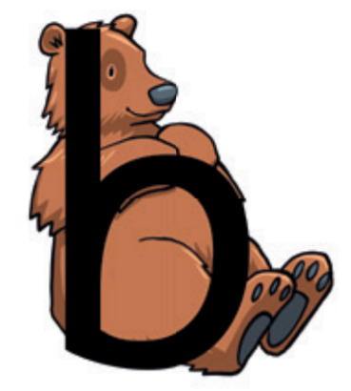

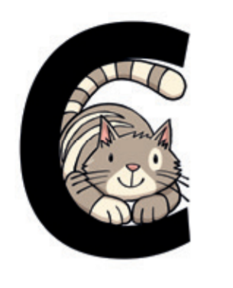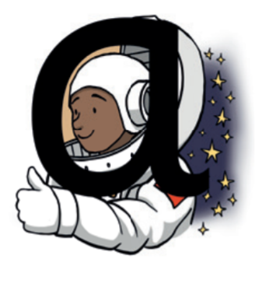

Around the astronaut’s helmet and down into space.

Round the duck’s body, up to its head and down to its feet.

Curl around the cat.

Down bear’s back, up and round his big tummy.

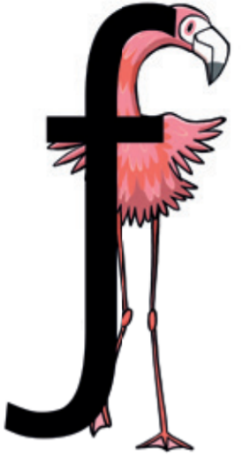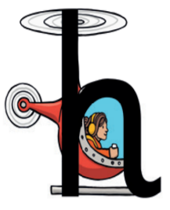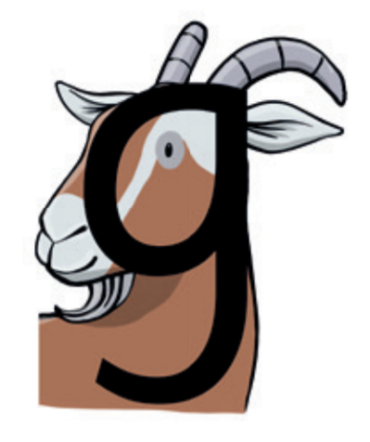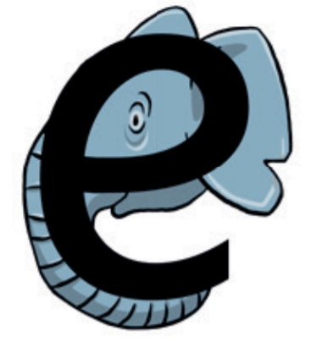

Down, up and over the helicopter.

Round the goat’s face, up to his ear, down and curl under his chin.

Down the flamingo’s neck, all the way to its foot, then across its wings.

Around the elephant’s eye and down its trunk.

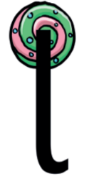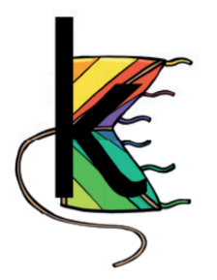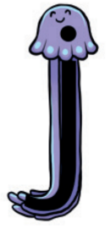

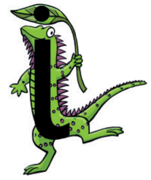

Down the iguana’s body, then draw a dot at the top

All the way down the lollipop.

Down the kite, up and across, back and down to the corner.

All the way down the jellyfish; dot on its head.

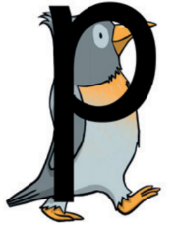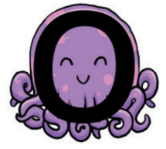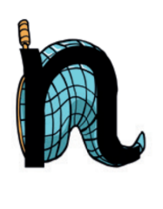

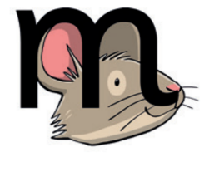

All around the octopus.

Down the penguin’s back, up and around its head.

Down the stick, up and over the net.

Down, up and over the mouse’s ears, then add a flick on the nose.

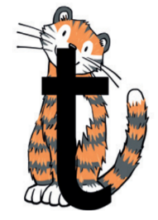

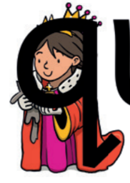

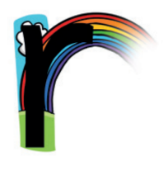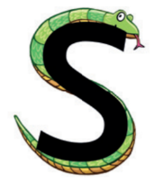

Round the queen’s face, up to her crown, down her robe with a flick at the end.

From the tiger’s nose to its tail, then follow the stripe across the tiger.

Under the snake’s chin, slide down and round its tail.

From the cloud to the ground, up the arch and over the rainbow.

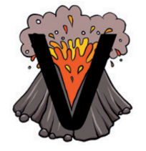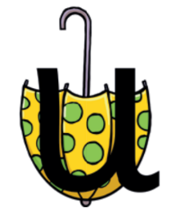

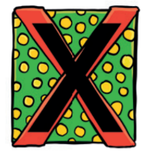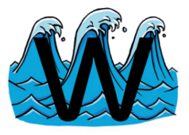

Down and around the umbrella, stop at the top and down to the bottom and flick.

Start at the top, then across to the bottom of the box.

From the top of the wave to the bottom, up the wave, down the wave, then up again.

Down to the bottom of the volcano and back up to the top.

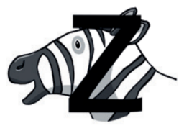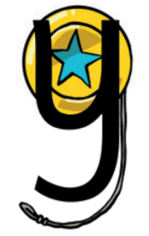

Zip across, zag down and across the zebra.

Down and round the yo-yo, then follow the string round.